NOTICE

Due to compelling circumstances, Semester 1 Examination of GBO students for Paper no. 1.6 Organisational Psychology has been rescheduled from 27-01-2021 to 01-02-2021 (Monday). Timing and mode of examination will remain the same.
All the students are required to take a note of this.
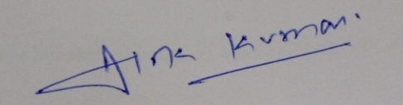
Dr. Alok Kumar
Deputy Superintendent
GBO Examination, January, 2021

